Hyperspectral Image Classification
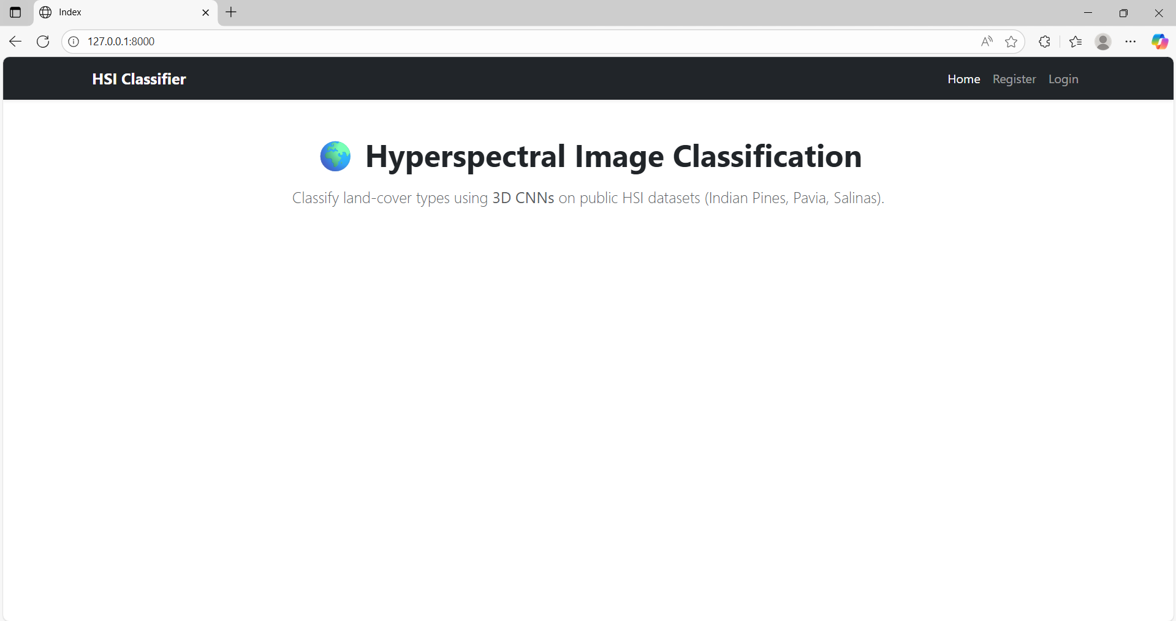
Open to Landing Page in http://127.0.0.1:8000/
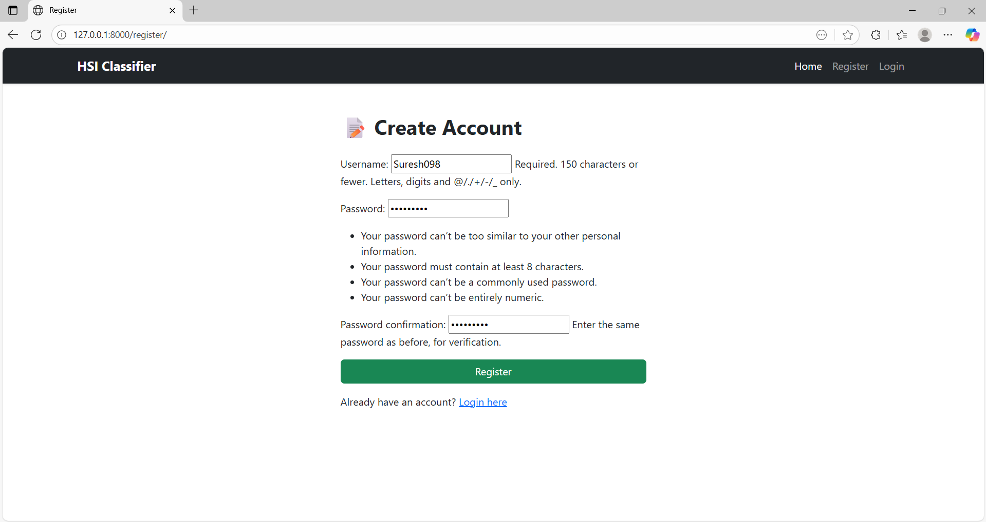
Click on Register Button in Username is special format, Password is case sensitive atlest one Capital Letter, one number, One Special Charecter
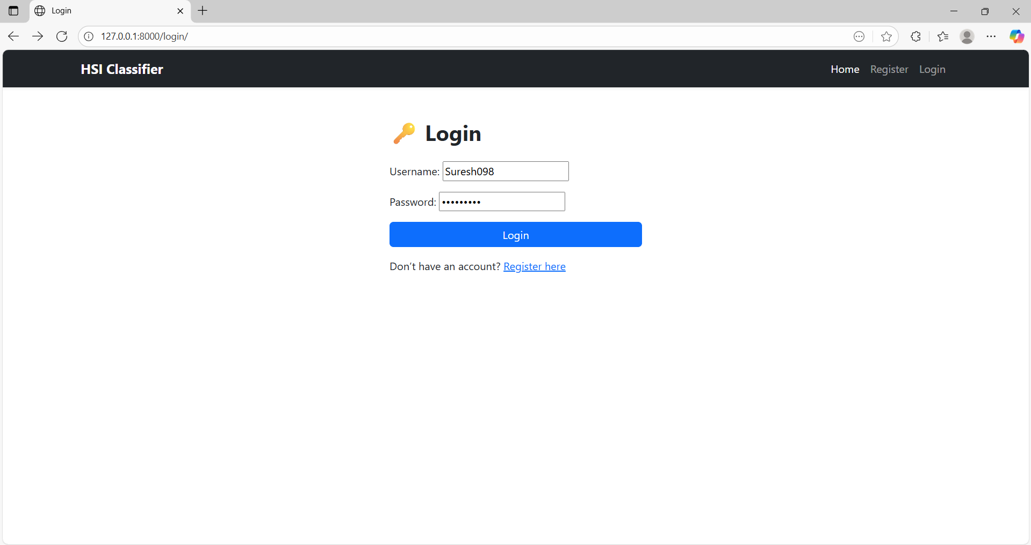
Next Login to this page
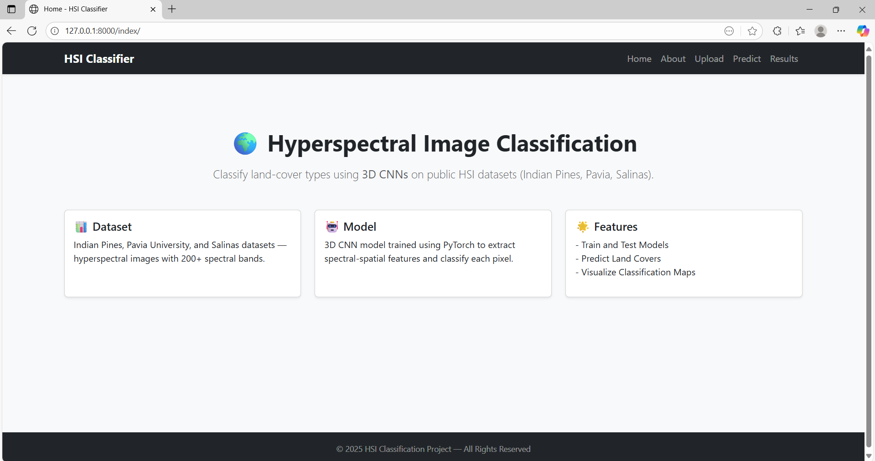
After login to open Home Page on the Display
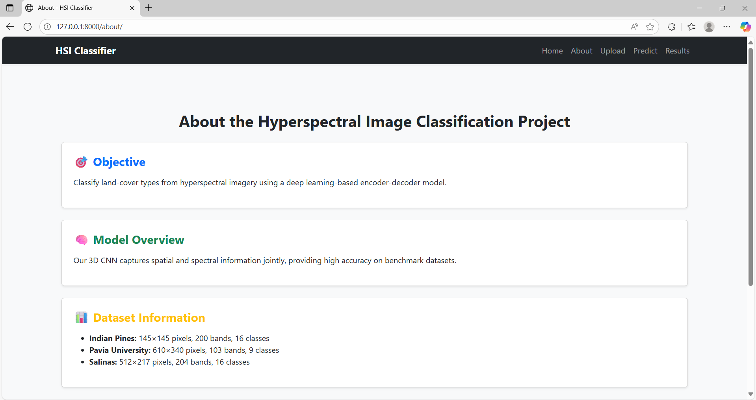
Next what about this project to click on About button to open Project Some Details
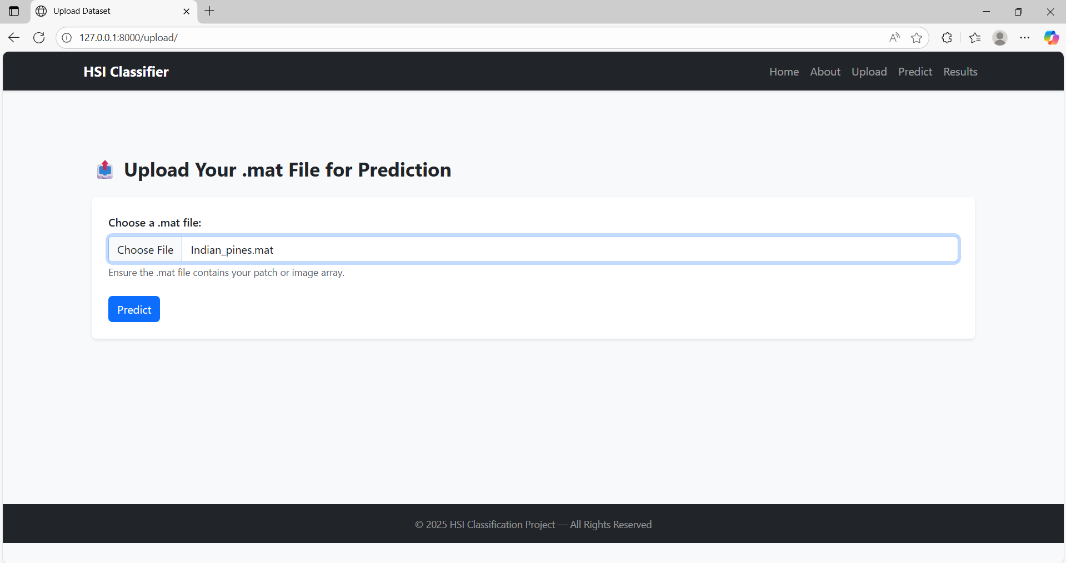
Next, In the nav bar Click on the Upload Button to open to Upload Page
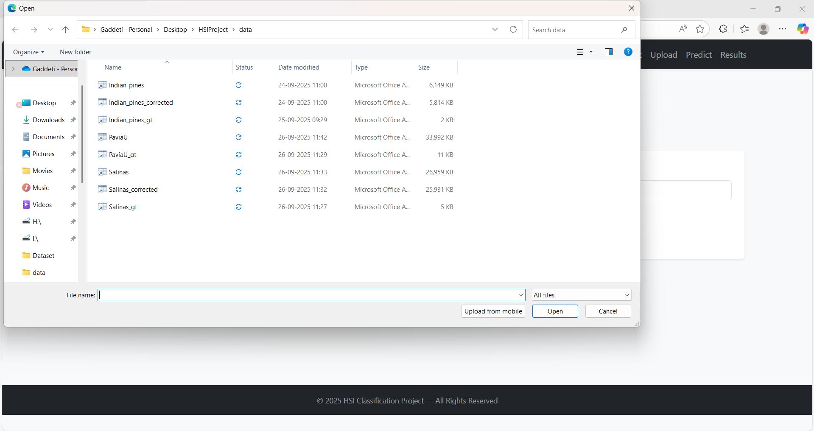
Next, Selected to test file in .mat files in uploaded

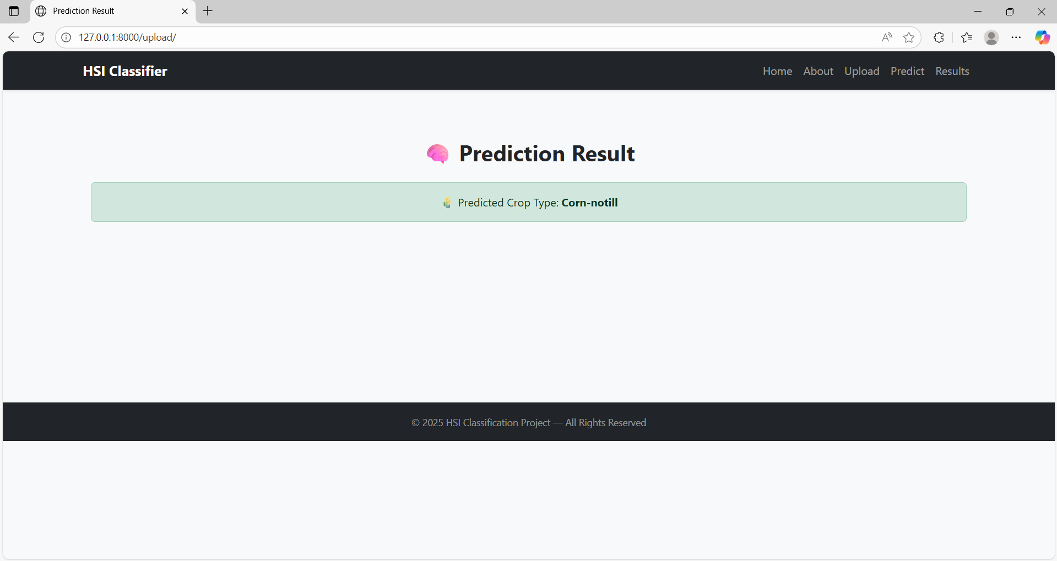
After Upload to Predicted to Crop type Prediction Results on the Display

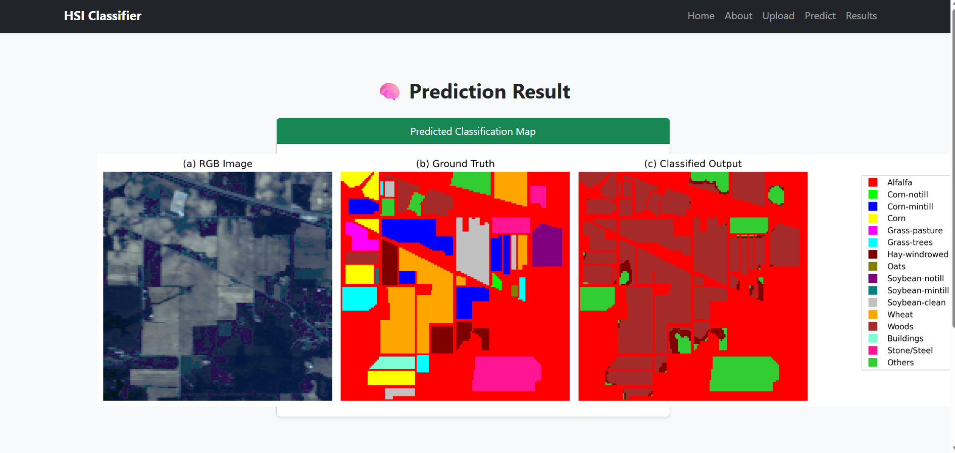
Next, predict button click to Prediction Classification map are displayed

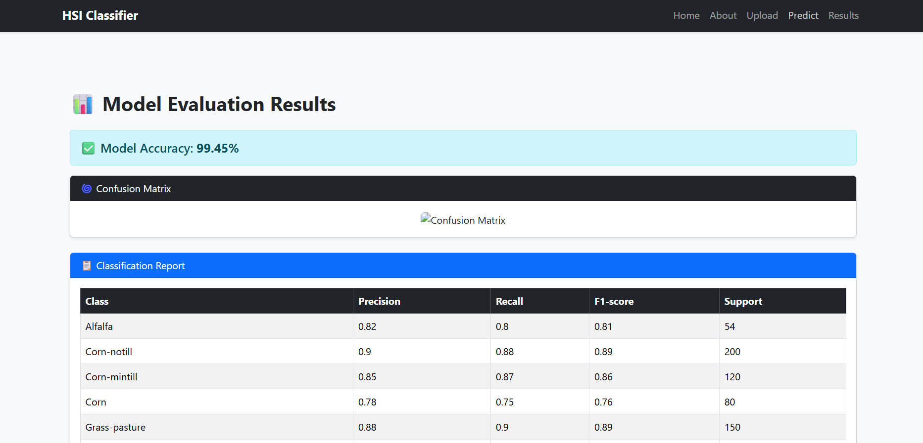
After click on Results in that page Model Evalution Results, confusion matrix, Classification Report on the Displayed
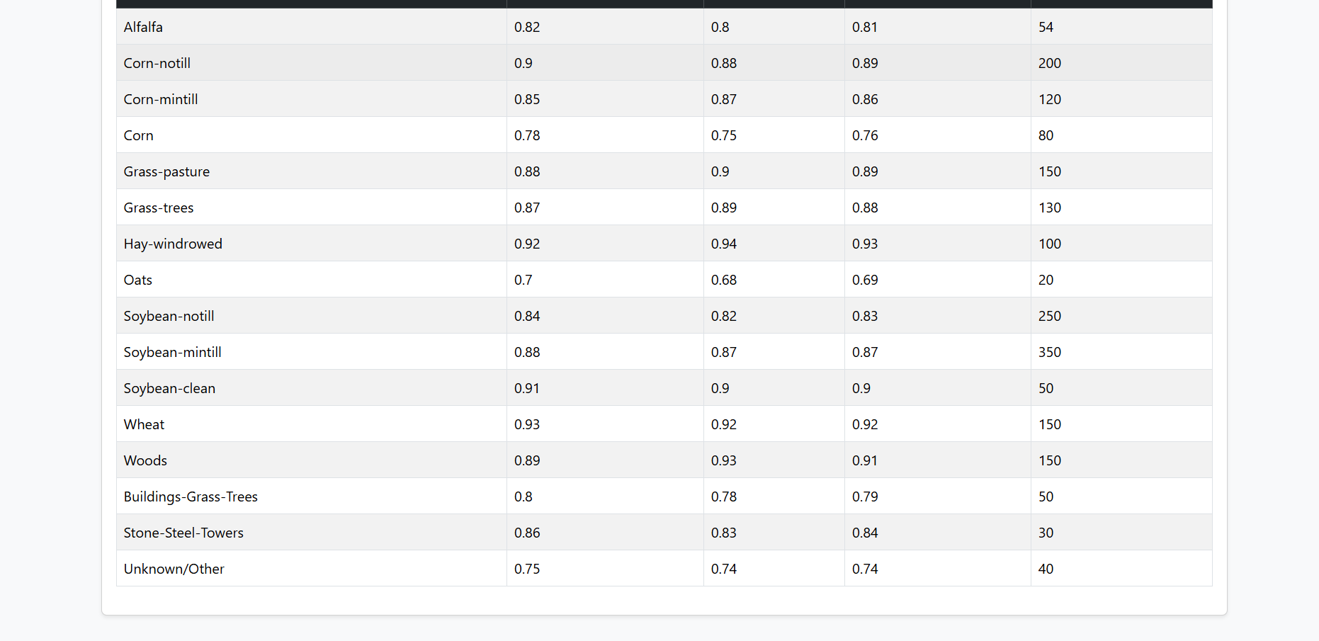

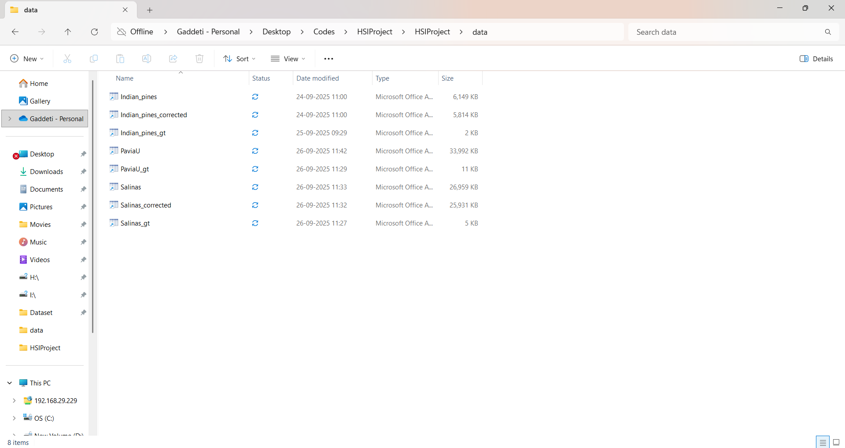If you have add another datasets added to first add dataset folder placed
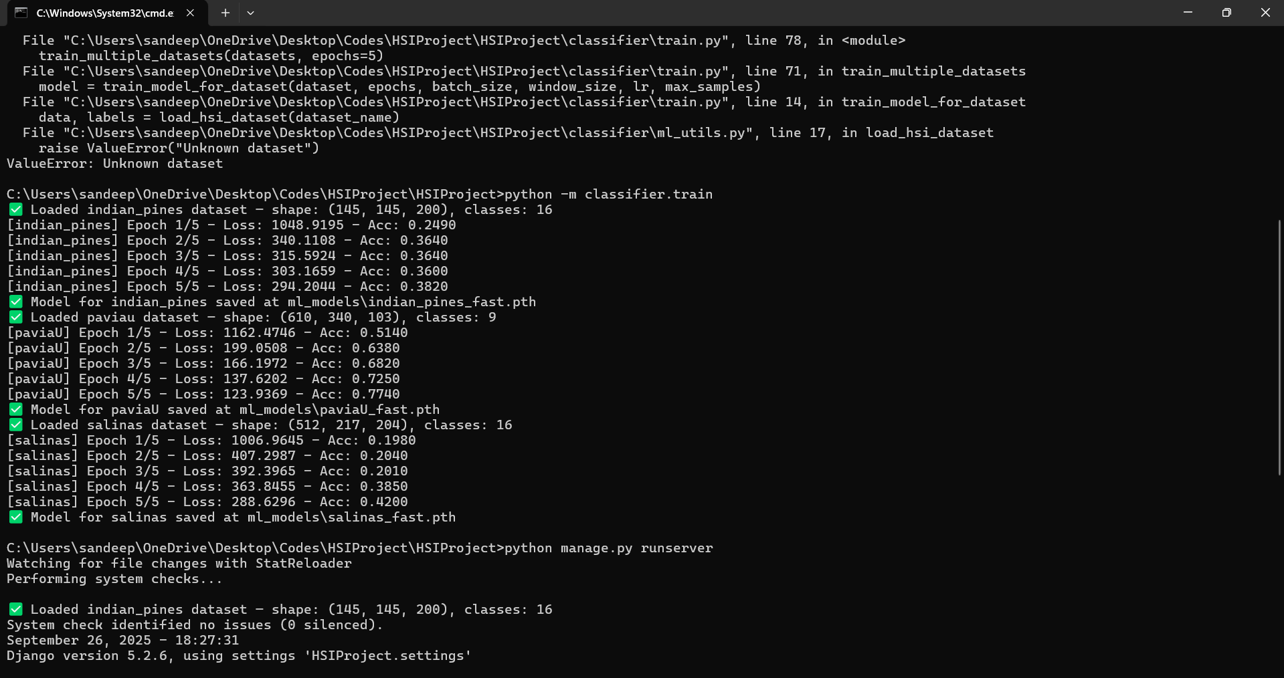
Next train.py file has trained to create .h5 files created automatically
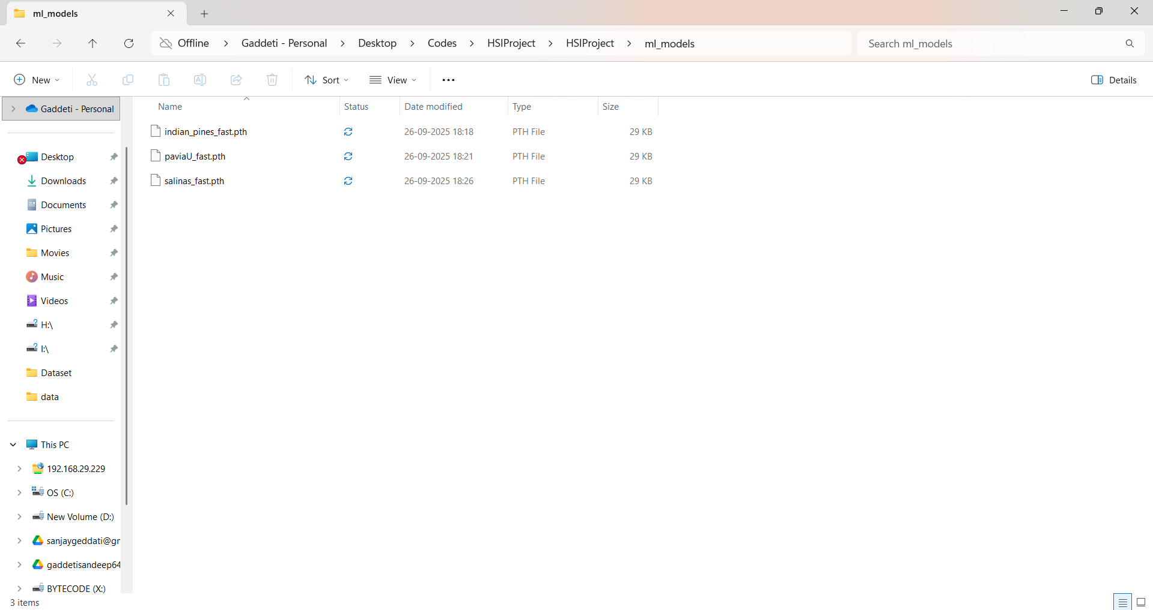
ml_models folder inside automatically saved
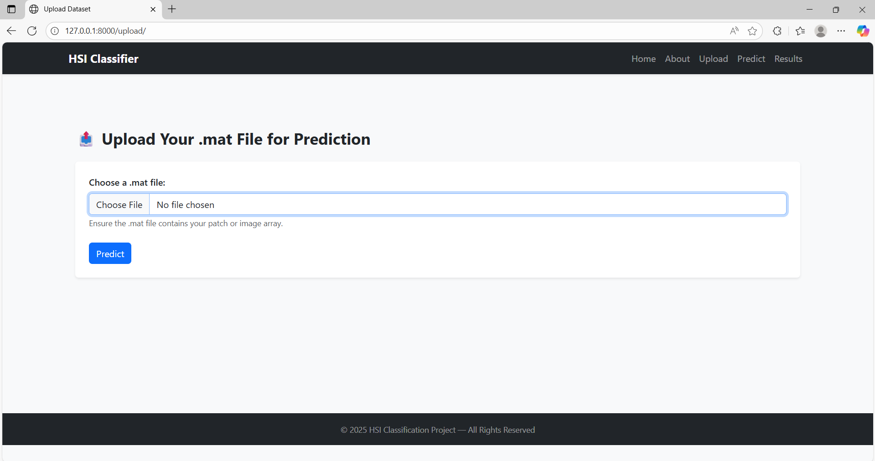
Next Uploading
put displayed

